MUJTABA SHAHID FAIZI
BSCS-5A
#131818
LAB 9 OF OS

TASK 1:
#include<stdio.h>
void main(){
int a=0;
printf("Enter number of segments\n");
scanf("%d",&a);
int seg[2*a]; //will store base nd bound of each segment so, size=2*number of segments
int i=0,j=1;
for(j=1;j<=a;j++){
printf("Enter base address of segment %d\n",j);
scanf("%d",&seg[i]);
i=i+2;
}
j=1,i=1;
for(j=1;j<=a;j++){
printf("Enter bound address of segment %d\n",j);
scanf("%d",&seg[i]);
i=i+2;
}

int s=0,log=0;
printf("Enter segment number: ");
scanf("%d",&s);
printf("Enter logical address: ");
scanf("%d",&log);

int segbound=seg[(2*s)-1]; //actual bound of the user specified segment number
int segbase=seg[s-1]; //actual base of the user specified segment number
if(log>segbound || log<segbase){
printf("Error!Out of bounds\n");
}
else{
printf("Segment number\t");
printf("Base address\t");
printf("Physical address\n");
printf("%d\t\t",s);
printf("%d\t\t",segbase);
printf("%d\n",log+segbase);
}
}

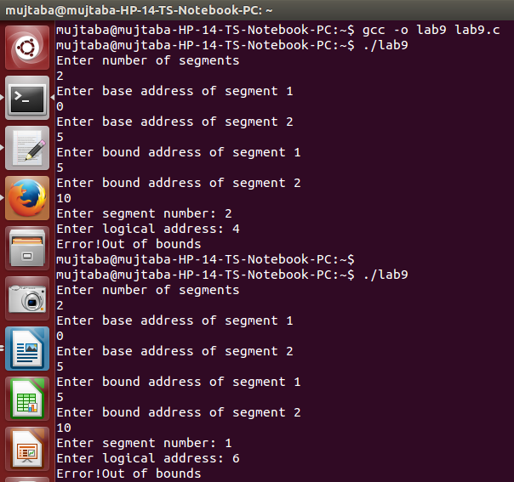
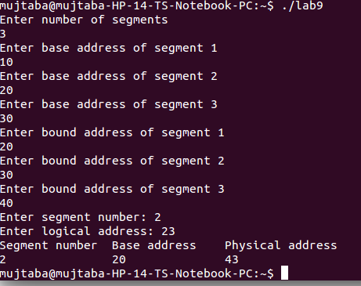
Task2:

#include<stdio.h>
void main(){
long int phy=0;
printf("Enter physical address\n");
scanf("%ld",&phy);
unsigned int page=phy/4096;
unsigned int startadd=page*4096;
unsigned int offset=phy%4096;
printf("Page number\t");
printf("Start address\t");
printf("Offset\n");
printf("%d\t\t",page);
printf("0*%x\t\t",startadd); //in hexadecimal
printf("%d\t\t",offset);
}
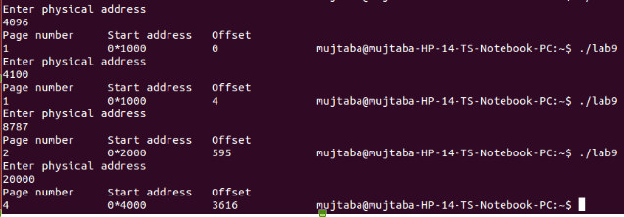

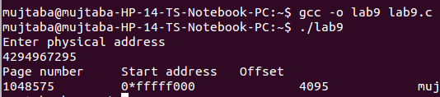
Task 3: 0X part of the starting addresses remains same. C language uses it as prefix to tell the compiler that the base is hexadecimal.

